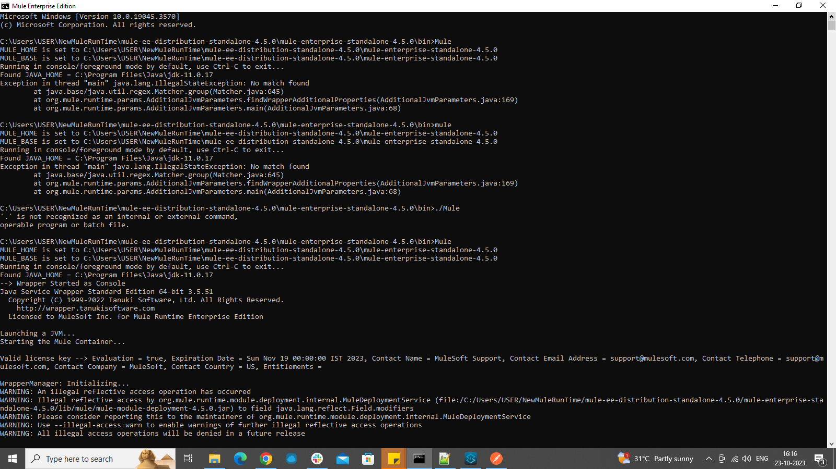

Solution:

Changes in wrapper. conf file causing this issue. Reverted the changes (adding Anypoint credentials in wrapper. conf file)

Error while taking API from exchange:

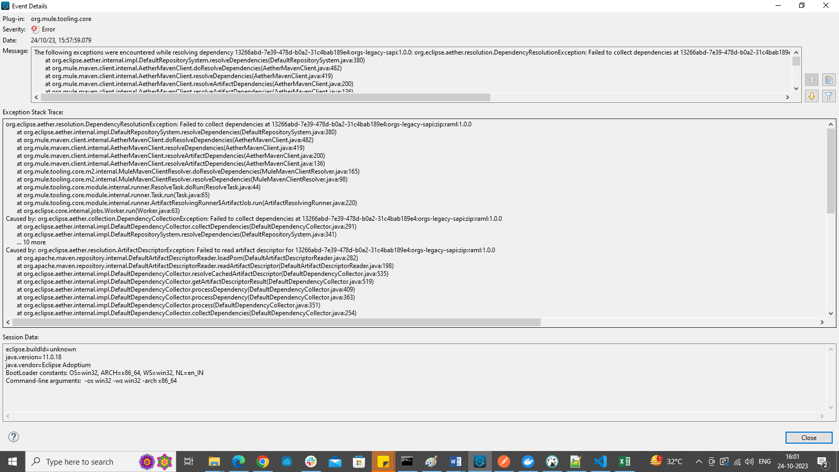

Error-out of memory issue:

Change memory size to 3200m min wrapper. Conf file at point number 7

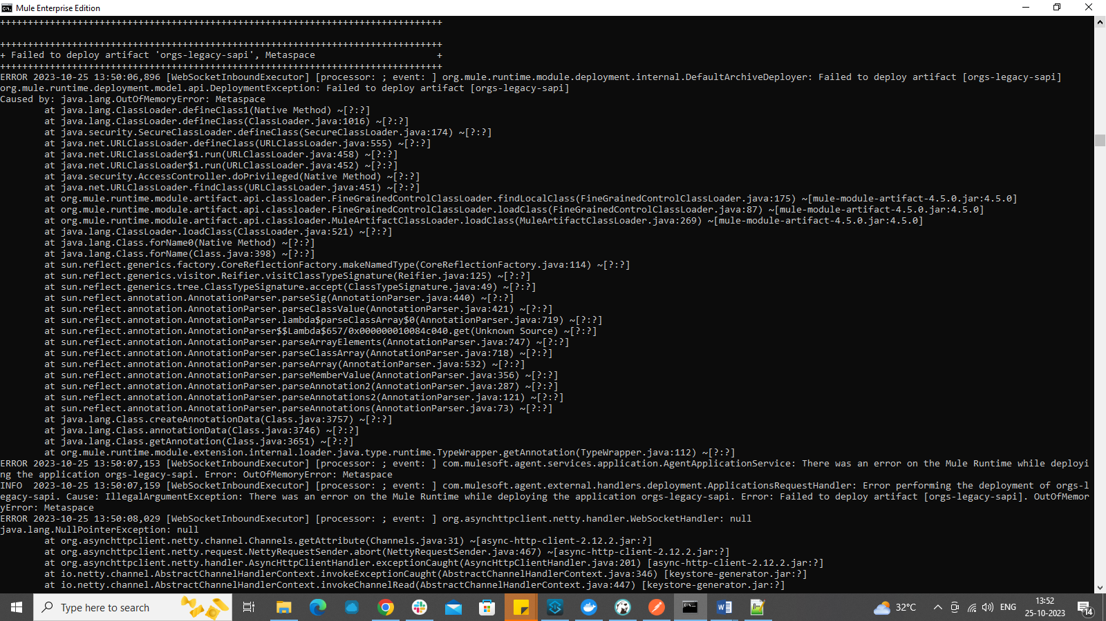

Error-scaffolding:

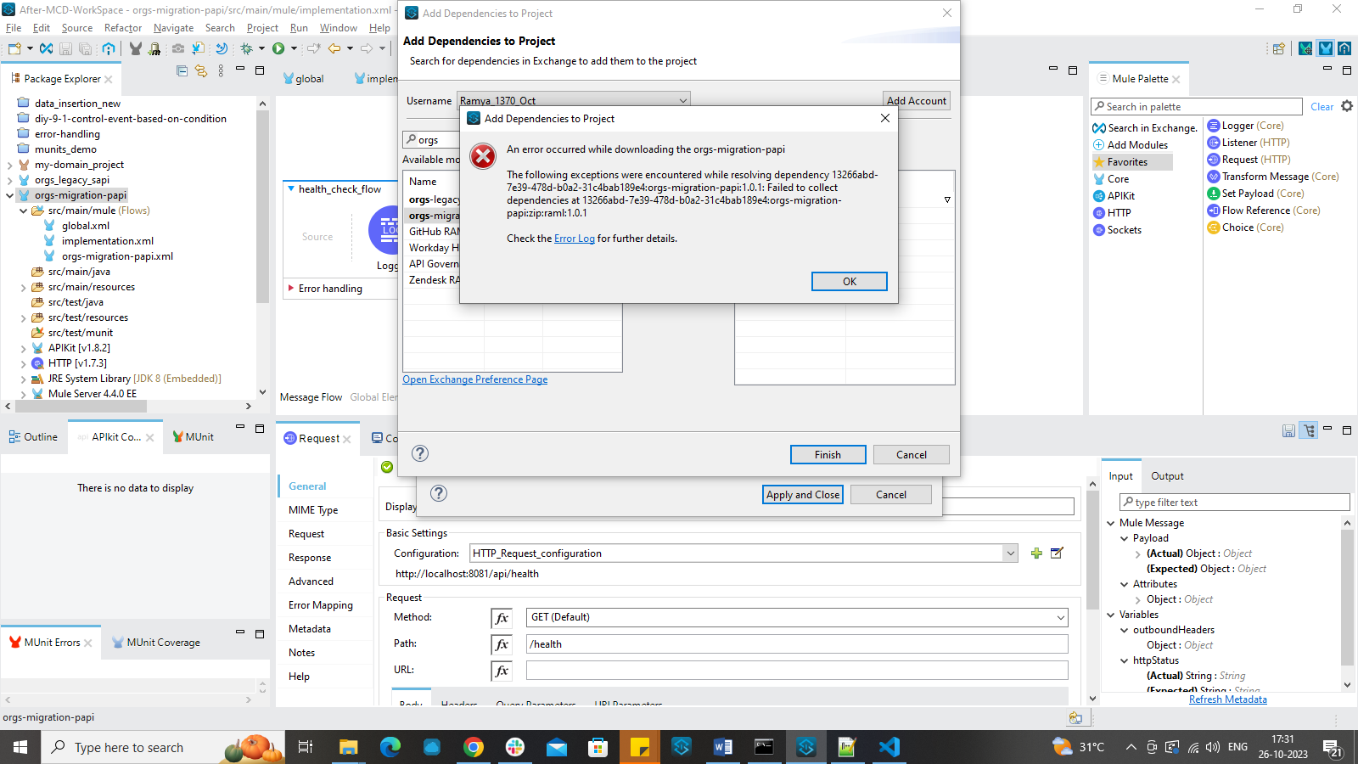

Solution: Connected app credentials in settings.xml were commented since they got connected to an account whose 30-day trial is completed.

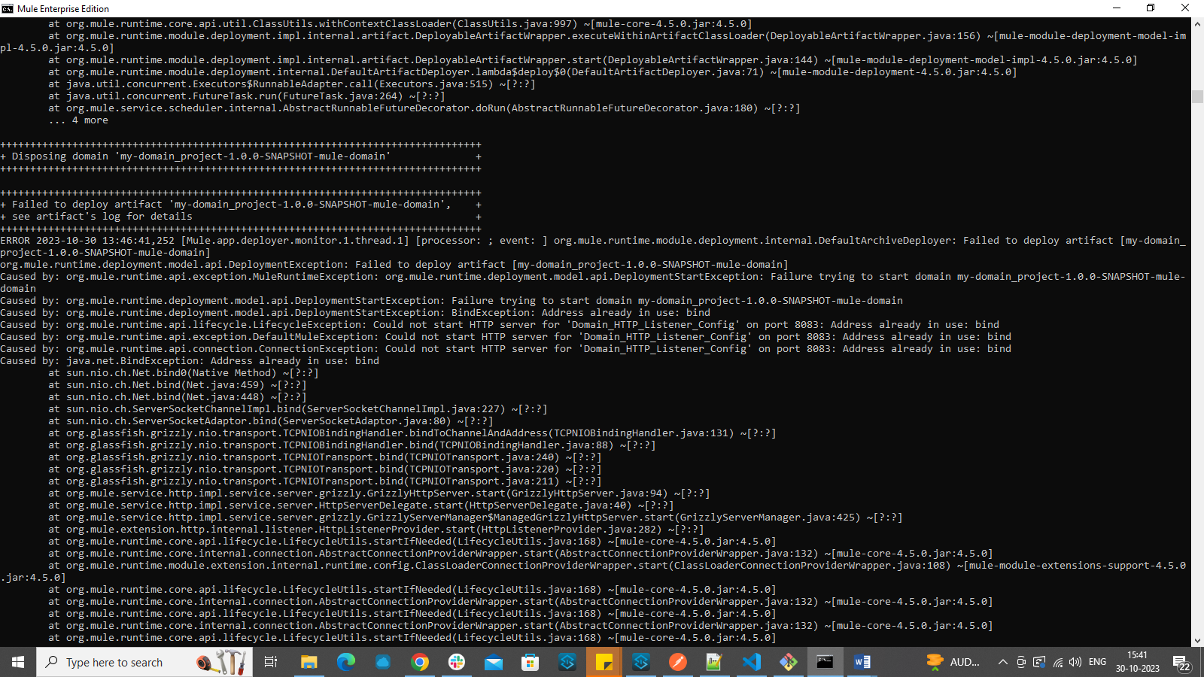

Solution:

You need to stop the application in Anypoint Studio and Deploy the app in Hybrid server.

First deploy the domain project and then deploy the actual app.

Check that before starting server, the app is not running in Anypoint studio.

Git errors:

USER@DESKTOP-DBCF8RU MINGW64 ~/AnypointStudio/After-MCD-WorkSpace/Postgres-Salesforce-Migration (master)

$ git init

Reinitialized existing Git repository in C:/Users/USER/AnypointStudio/After-MCD-

WorkSpace/Postgres-Salesforce-Migration/.git/

USER@DESKTOP-DBCF8RU MINGW64 ~/AnypointStudio/After-MCD-WorkSpace/Postgres-Salesforce-Migration (master)

$ git branch -M master

USER@DESKTOP-DBCF8RU MINGW64 ~/AnypointStudio/After-MCD-WorkSpace/Postgres-Salesforce-Migration (master)

$ git add .

warning: adding embedded git repository: implementation/migration-papi/pg-sf-mig

ration-papi

hint: You've added another git repository inside your current repository.

hint: Clones of the outer repository will not contain the contents of

hint: the embedded repository and will not know how to obtain it.

hint: If you meant to add a submodule, use:

hint:

hint: git submodule add <url> implementation/migration-papi/pg-sf-migration-pa

pi

hint:

hint: If you added this path by mistake, you can remove it from the

hint: index with:

hint:

hint: git rm --cached implementation/migration-papi/pg-sf-migration-papi

hint:

hint: See "git help submodule" for more information.

warning: adding embedded git repository: implementation/orgs-legacy-sapi/orgs_le

gacy_sapi

warning: adding embedded git repository: implementation/salesforce-sapi/Salesfor

ce-SAPI-Task

USER@DESKTOP-DBCF8RU MINGW64 ~/AnypointStudio/After-MCD-WorkSpace/Postgres-Salesforce-Migration (master)

$ git status

On branch master

No commits yet

Changes to be committed:

(use "git rm --cached <file>..." to unstage)

new file: .vscode/settings.json

new file: README.md

new file: apis/orgs-legacy-sapi.zip

new file: apis/orgs-migration-papi.zip

new file: apis/salesforce-sapi.zip

new file: docs/TDD.md

new file: docs/image-1.png

new file: docs/image.png

new file: docs/papi.puml

new file: docs/pg-sf-migration-sequence-diagram.png

new file: implementation/migration-papi/pg-sf-migration-papi

new file: implementation/orgs-legacy-sapi/orgs_legacy_sapi

new file: implementation/salesforce-sapi/Salesforce-SAPI-Task

Changes not staged for commit:

(use "git add <file>..." to update what will be committed)

(use "git restore <file>..." to discard changes in working directory)

(commit or discard the untracked or modified content in submodules)

modified: implementation/migration-papi/pg-sf-migration-papi (untracke

d content)

modified: implementation/orgs-legacy-sapi/orgs_legacy_sapi (untracked

content)

modified: implementation/salesforce-sapi/Salesforce-SAPI-Task (untrack

ed content)

USER@DESKTOP-DBCF8RU MINGW64 ~/AnypointStudio/After-MCD-WorkSpace/Postgres-Salesforce-Migration (master)

$